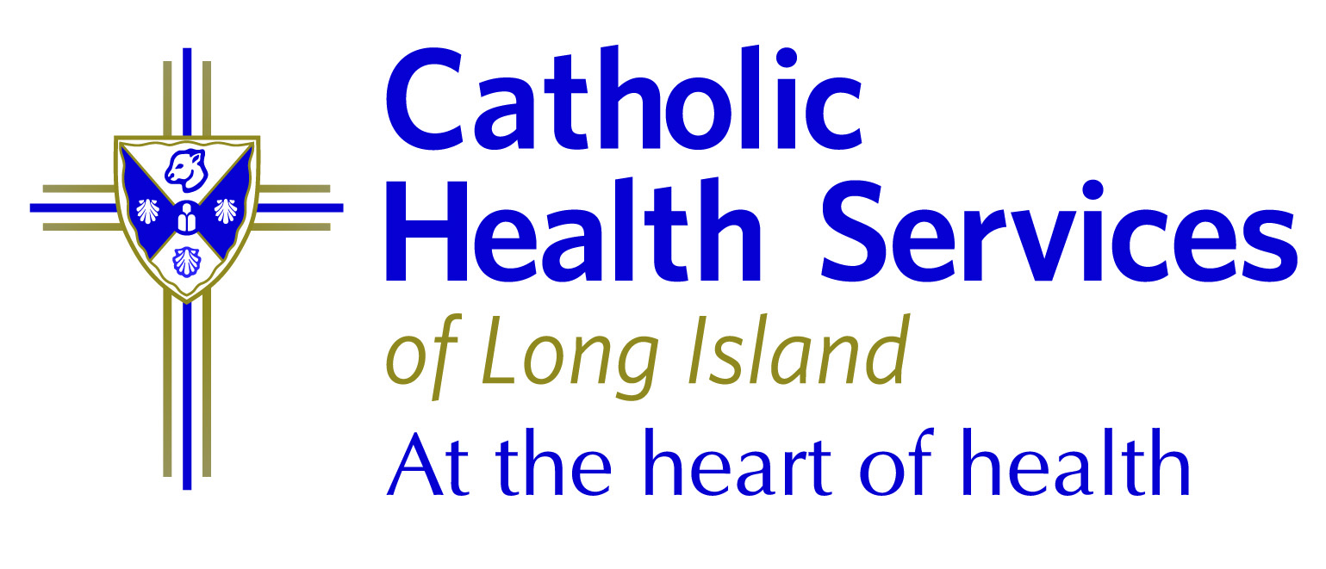

FOR IMMEDIATE RELEASE: Contact: Chris Hendriks, VP
PR & Communications
March 20, 2020 516-705-3947
Greg Sleter, PR & Brand Manager
631-828-7418

Catholic Health Services Offers Tips to Reduce COVID-19 Anxiety

ROCKVILLE CENTRE, NY – As coronavirus continues to impact Long Islanders, growing health concerns along with the constant barrage of news is raising people’s anxiety.
Catholic Health Services’s (CHS) mental health professionals offer ways we can reduce our stress during this time of uncertainty. This includes eating healthy, exercise, adequate sleep, virtually connecting with friends and family and reducing exposure to news and social media.
“The constant flow of information related to coronavirus can become overwhelming,” said Catholic Health Services Chairman of Behavioral Health Ronald Brenner, MD. “It’s important to take a break and step away from media reports and the constant scrolling through social channels.”
Anxiety is a normal response to a stressful situation and can inspire adaptive behavior in many situations. However, when facing mounting uncertainty, the brain can go into an anxiety spiral and cause atypical reactions. Knowing the body’s physical reactions to the different types of anxiety is important.
Typical stress reactions can include temporary difficulty concentrating, irritability, fatigue, stomachache and difficulty sleeping. Atypical reactions can manifest in persistent and/or excessive worry that prevents you from completing daily tasks, changes to energy levels, eating patterns and/or prolonged and overwhelming worry. Dr. Brenner strongly suggests that anyone experiencing unusual or atypical reactions that won’t subside in a short period of time seek professional mental health assistance.
To reduce coronavirus-related anxiety, there are several steps individuals can take. These include:
- Find meaningful tasks and roles within your support network to channel your anxiety
- Create spaces that are not focused on coronavirus. This could include a social media thread on other topics, or watching movies
- Savor small positive moments, amplify positive stories and stay optimistic
- Practice mindfulness when managing anxiety such as performing exercises and deep breathing.
For those who wish to speak to a mental health professional, CHS offers a host of services including Telepsychiatry, which improves access to psychiatric services for emergency department (ED) patients, particularly after normal office hours. The service is currently offered in the EDs of Mercy Medical Center in Rockville Centre, St. Catherine of Siena Medical Center in Smithtown and Good Samaritan Hospital Medical Center in West Islip.
More information on CHS’s mental health services may be obtained by calling 1(855) CHS-4500.
About Catholic Health Services
CHS is an integrated system encompassing some of the region’s finest health and human services agencies. With 18,000 employees, 6 acute care hospitals, 3 nursing homes, a home nursing service, hospice, a community-based agency for persons with special needs and a network of physician practices, CHS’s high standards have resulted in a 24% market share.
###

